**DAILY ONLINE ACTIVITIES SUMMARY**

|  |  |  |  |  |  |  |  |  |
| --- | --- | --- | --- | --- | --- | --- | --- | --- |
| **Date:** | **12/06/2020** | | | | | **Name:** | **POOJA D S** | |
| **Sem & Sec** | **4th Sem 'B' Section** | | | | | **USN:** | **4AL18CS056** | |
| **Online Test Summary** | | | | | | | | |
| **Subject** | | **Aadalitha Kannada** | | | | | | |
| **Max. Marks** | | **25** | | **Score** | | | **18** | |
| **Certification Course Summary** | | | | | | | | |
| **Course** | **Introduction to Ethical Hacking** | | | | | | | |
| **Certificate Provider** | | | **Great Learning Academy** | | **Duration** | | | **4 hour** |
| **Coding Challenges** | | | | | | | | |
| **Problem Statement:** A user will input two strings, and we find if one of the strings is a sub sequence of the other. Program prints “yes” if either the first string is a sub sequence of the second string or the second string is a sub sequence of the first string. Assume that, the length of the first string is smaller than or equal to the length of the second string. Assume that, the length of the first string is smaller than or equal to the length of the second string. | | | | | | | | |
| **Status: completed** | | | | | | | | |
| **Uploaded the report in Github** | | | | | **yes** | | | |
| **If yes Repository name** | | | | | <https://github.com/dspooja/Java-coding/blob/master/june%2012th%20prime_number.py> | | | |
| **Uploaded the report in slack** | | | | | **yes** | | | |

Online Test Details: (Attach the snapshot and briefly write the report for the same)

Certification Course Details: (Attach the snapshot and briefly write the report for the same)

Coding Challenges Details: (Attach the snapshot and briefly write the report for the same)

ONLINE TEST DETAILS:

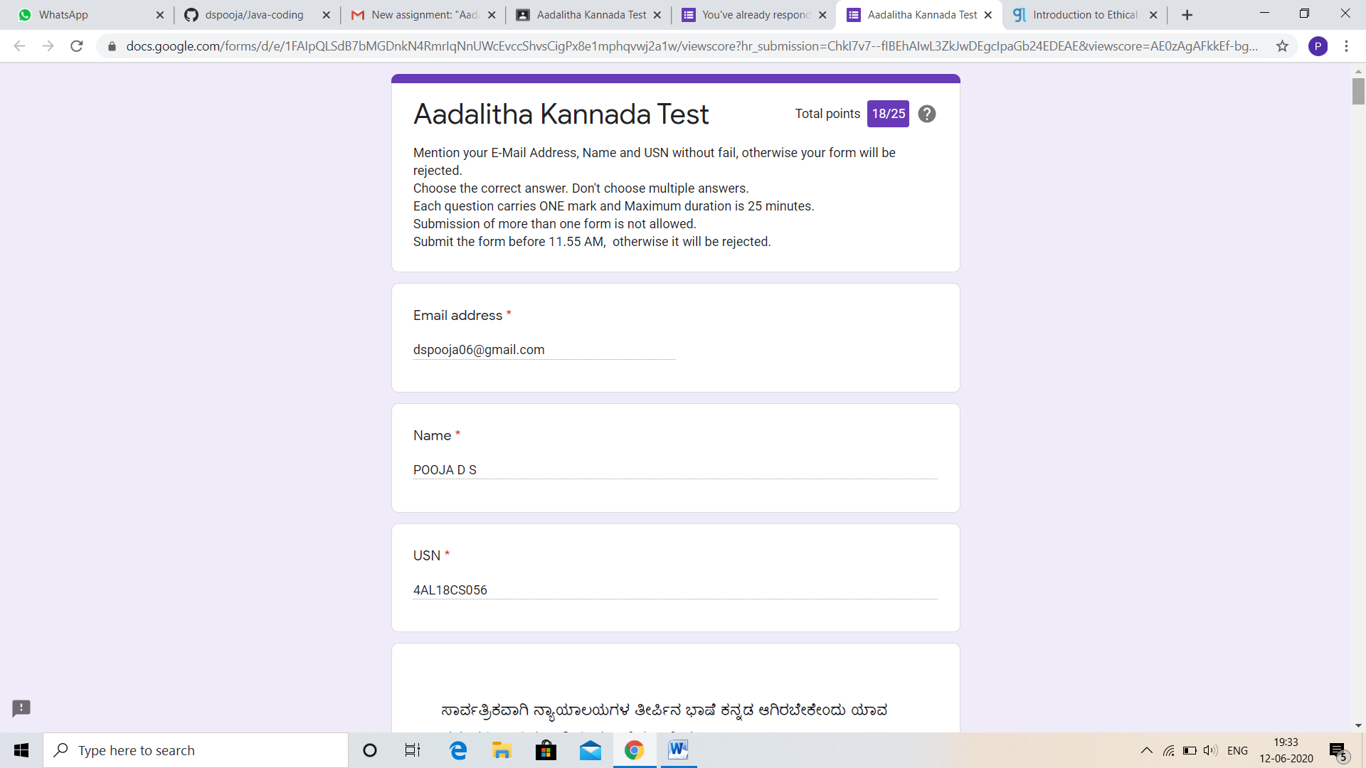

CERTIFICATION COURSE DETAILS:

* As continuation of the **Introduction to Ethical Hacking** online course**.**
* **The concepts covered in Introduction to Ethical Hacking are:**
* Career and Growth Ladder in Ethical Hacking
* Domains and Process Implementation under Ethical Hacking

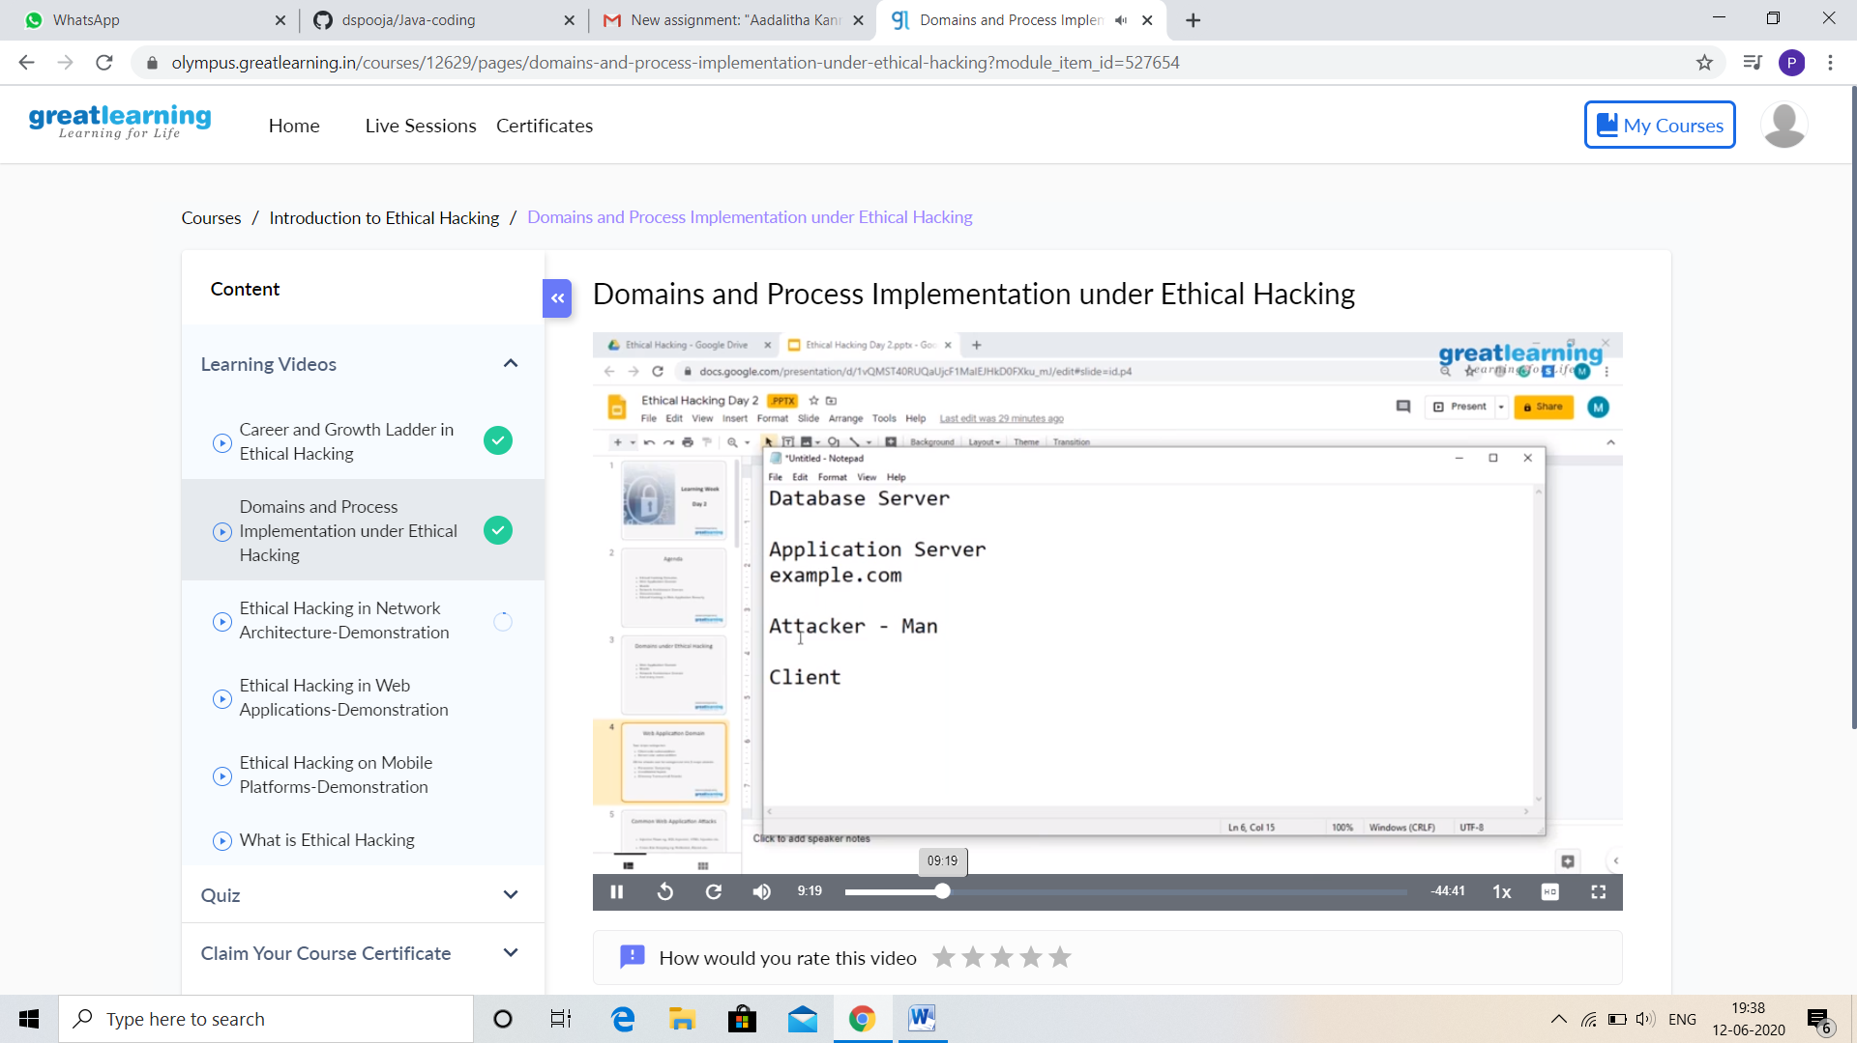

And I participate yesterday Webinar on Skill development.

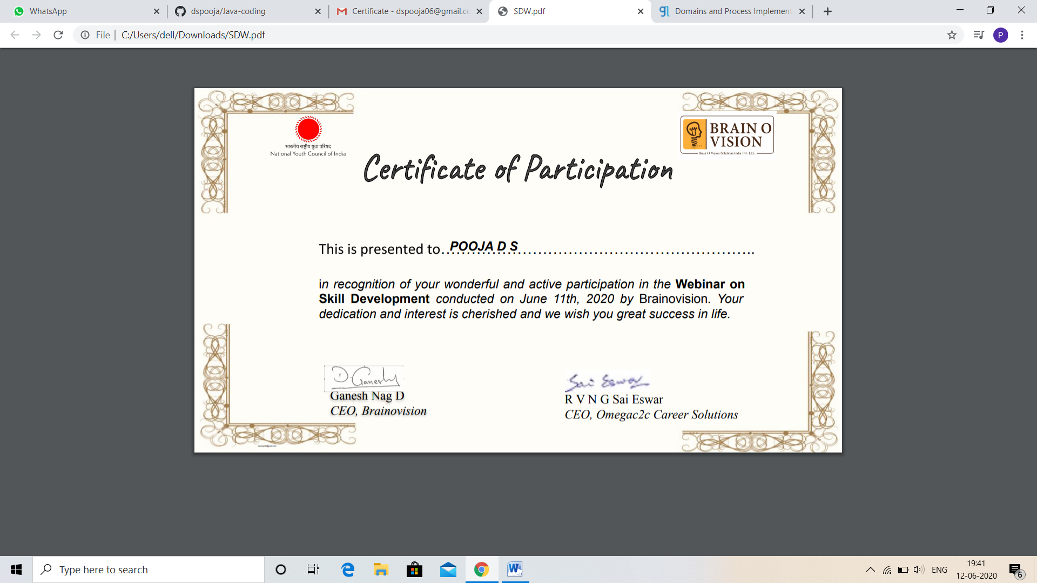

CODING CHALLENGES DETAILS:

Problem statement 1:

Given two positive integer start and end. The task is to write a Python program to print all Prime numbers in an Interval.

Explanation: A prime number is a natural number greater than 1 that has no positive divisors other than 1 and itself. The first few prime numbers are {2, 3, 5, 7, 11 ,….}. The idea to solve this problem is to iterate the value from start to end using a for loop and for every number, if it is greater than 1, check if it divides n. If we find any other number which divides, print that value.

Solution: Uploaded it in github.

